
FOR IMMEDIATE RELEASE
Contact: Zoe Dell, zoe.dell@arkansas.gov

Arkansas’ unemployment rate rose to 4.1% in November
LITTLE ROCK, Ark. (Jan. 7, 2026) Today, the Arkansas Department of Commerce, in conjunction with the Bureau of Labor Statistics, announced Arkansas’ seasonally adjusted unemployment rate increased to 4.1% in November, up from 3.9% in September. The United States’ jobless rate reached 4.6% in November, compared to 4.4% in September. October 2025 Civilian Labor Force data is not available.*
Arkansas Civilian Labor Force Summary:
- Arkansas’ civilian labor force rose to 1,439,250 in November, an increase of 8,633 since September. Both employed (+4,999) and unemployed actively seeking work (+3,634) increased compared to September. Arkansas’ labor force participation rate continues to climb, reaching 58.8% in November.
- Compared to November 2024, there are 13,154 more employed and 8,887 additional unemployed Arkansans actively seeking work. These increases resulted in a rise of five-tenths of a percentage point in both the unemployment rate and the labor force participation rate over the year.
Arkansas Nonfarm Payroll Job Summary:
- Nonfarm payroll jobs in Arkansas declined by 700 in November. Professional and Business Services posted the largest decrease (-1,400). Most of the losses were in Administrative and Support Services, down 1,200. Other losses were small and mostly due to seasonal fluctuations. Jobs in Trade-Transportation-Utilities rose by 2,500, with Retail Trade adding 2,300 jobs at the start of the holiday shopping season.
- Compared to November 2024, Arkansas’ nonfarm payroll jobs are up 17,600. Leisure and Hospitality (+6,700), Private Education and Health Services (+4,900), and Trade-Transportation-Utilities (+4,700) reported the largest annual job growth. The greatest loss was in Construction, down 2,200 jobs over the year.

Arkansas Civilian Labor Force (Seasonally Adjusted)

 | November  2025 | October 2025* | September  2025 | November  2024 | Change from October 2025* | Change from September 2025 | Change from November 2024
Civilian Labor Force | 1,439,250 | - | 1,430,617 | 1,417,209 | - | 8,633 | 22,041
Employment | 1,379,866 | - | 1,374,867 | 1,366,712 | - | 4,999 | 13,154
Unemployment | 59,384 | - | 55,750 | 50,497 | - | 3,634 | 8,887
Unemployment Rate | 4.1% | - | 3.9% | 3.6% | - | 0.2% | 0.5%
Labor Force Participation Rate | 58.8% | - | 58.5% | 58.3% | - | 0.3% | 0.5%
Source: U.S. Bureau of Labor Statistics, Current Population Survey. More information about the data is available at https://www.bls.gov/cps/definitions.htm

*The Current Population Survey was not conducted in October 2025, due to the lapse in appropriations. This resulted in missing Civilian Labor Force data for October 2025 that cannot be calculated retroactively in real time.

Arkansas Nonfarm Payroll Jobs (Not Seasonally Adjusted, In Thousands)
Industry Sector based on 2022 North American Industry Classification System (NAICS) | November  2025 | October  2025 | November  2024 | Change  from October  2025 | Change  from November  2024
Total Nonfarm Payroll Jobs | 1400.0 | 1400.7 | 1382.4 | -0.7 | 17.6
Goods Producing | 235.8 | 236.8 | 236.2 | -1.0 | -0.4
Mining, Logging, & Construction | 70.6 | 70.8 | 72.7 | -0.2 | -2.1
Mining & Logging | 5.2 | 5.2 | 5.1 | 0.0 | 0.1
Construction | 65.4 | 65.6 | 67.6 | -0.2 | -2.2
Specialty Trade Contractors | 40.6 | 40.9 | 42.3 | -0.3 | -1.7
Manufacturing | 165.2 | 166.0 | 163.5 | -0.8 | 1.7
Durable Goods | 78.7 | 79.5 | 78.1 | -0.8 | 0.6
Nondurable Goods | 86.5 | 86.5 | 85.4 | 0.0 | 1.1
Service Providing | 1164.2 | 1163.9 | 1146.2 | 0.3 | 18.0
Trade, Transportation, & Utilities | 277.3 | 274.8 | 272.6 | 2.5 | 4.7
Wholesale Trade | 53.5 | 53.9 | 54.2 | -0.4 | -0.7
Retail Trade | 148.7 | 146.4 | 144.7 | 2.3 | 4.0
Transportation, Warehousing, & Utilities | 75.1 | 74.5 | 73.7 | 0.6 | 1.4
Information | 11.7 | 11.7 | 12.0 | 0.0 | -0.3
Financial Activities | 70.3 | 70.4 | 70.7 | -0.1 | -0.4
Finance & Insurance | 55.2 | 55.3 | 55.2 | -0.1 | 0.0
Real Estate, Rental, & Leasing | 15.1 | 15.1 | 15.5 | 0.0 | -0.4
Professional & Business Services | 164.7 | 166.1 | 161.2 | -1.4 | 3.5
Professional, Scientific, & Technical | 53.4 | 53.3 | 51.7 | 0.1 | 1.7
Management of Companies | 42.0 | 42.3 | 39.9 | -0.3 | 2.1
Administrative & Support Services | 69.3 | 70.5 | 69.6 | -1.2 | -0.3
Private Education & Health Services | 224.2 | 224.3 | 219.3 | -0.1 | 4.9
Educational Services | 19.7 | 19.6 | 20.4 | 0.1 | -0.7
Health Care & Social Assistance | 204.5 | 204.7 | 198.9 | -0.2 | 5.6
Ambulatory Health Care | 72.0 | 72.4 | 68.8 | -0.4 | 3.2
Social Assistance | 44.3 | 44.2 | 42.2 | 0.1 | 2.1
Leisure & Hospitality | 134.7 | 135.3 | 128.0 | -0.6 | 6.7
Arts, Entertainment, & Recreation | 13.8 | 14.4 | 13.5 | -0.6 | 0.3
Accommodation & Food Services | 120.9 | 120.9 | 114.5 | 0.0 | 6.4
Accommodation Services | 11.5 | 11.6 | 10.9 | -0.1 | 0.6
Food Services | 109.4 | 109.3 | 103.6 | 0.1 | 5.8
Other Services | 65.1 | 65.5 | 65.8 | -0.4 | -0.7
Government | 216.2 | 215.8 | 216.6 | 0.4 | -0.4
Federal Government | 20.4 | 20.4 | 21.9 | 0.0 | -1.5
State Government | 78.3 | 78.2 | 78.1 | 0.1 | 0.2
State Government, Educational Services | 32.3 | 32.2 | 32.1 | 0.1 | 0.2
State Government, Excluding Education | 46.0 | 46.0 | 46.0 | 0.0 | 0.0
Local Government | 117.5 | 117.2 | 116.6 | 0.3 | 0.9
Local Government, Educational Services | 71.6 | 71.5 | 71.1 | 0.1 | 0.5
Local Government, Excluding Education | 45.9 | 45.7 | 45.5 | 0.2 | 0.4
Source: Monthly Survey of Employers, based on 1st Quarter 2024 benchmark. Notes: Current month’s data are preliminary; previous month’s data are revised.

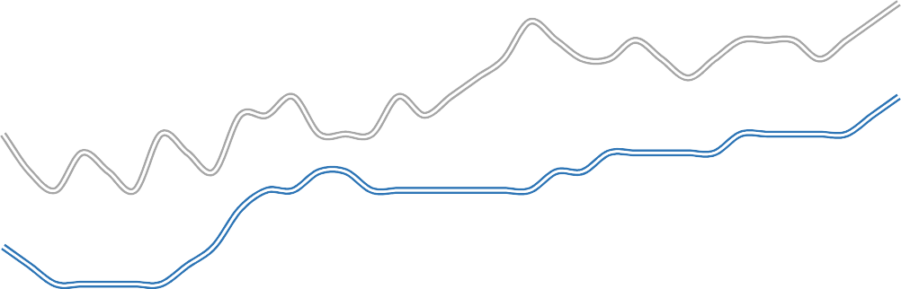
Seasonally Adjusted Unemployment Rates Arkansas vs. United States (3-Year Comparison)
5.0%
4.5%
4.0%
3.5%
3.0%
2.5%
2.0%
Nov '22
May '23
Nov '23
May '24
Nov '24
May '25
Nov '25
Arkansas
United States

Job Gains/Losses by Major Industry Sectors November 2024 to November 2025 (Not Seasonally Adjusted)
LEI S U R E & HO S P I T A LI T Y
6,700
P R I V AT E E D & H E AL T H
4,900
T R A D E - T RA N S P O RT - U T I LI T I ES
4,700
P R O F E S S I O N A L & B U S I N E S S
3,500
M A NU F A CT U R I NG
1,700
M I NI NG & LO GG I NG
100
I N FOR M AT I ON
-300
G OV E R N M E N T
-400
F I NA N CI A L A CT I V I T I ES
-400
OT H E R SE R V I C E S
-700
CO NS T R U CT I O N -2,200

-3,500
-1,000
1,500
4,000
6,500
9,000

For more Labor Market Data, visit our website at www.discover.arkansas.gov


About the Arkansas Department of Commerce
The Arkansas Department of Commerce is the umbrella department for workforce and economic development drivers. Its divisions and regulatory boards include the Division of Aeronautics, Waterways Commission, Wine Producers Council, Workforce Services, State Bank Department, Insurance Department, Securities Department, Economic Development Commission, and Development Finance Authority.

About Bureau of Labor Statistics (BLS)
The Bureau of Labor Statistics measures labor market activity, working conditions, price changes, and productivity In the U.S. economy to support public and private decision making.

About Local Area Unemployment Statistics (LAUS)
The LAUS program produces monthly and annual employment, unemployment, and labor force data for Census regions and divisions, States, counties, metropolitan areas, and many cities, by place of residence.
About Current Employment Statistics (CES)
The CES program produces detailed industry estimates of employment, hours, and earnings of workers on nonfarm payrolls. CES State and Metro Area produces data for all 50 States, the District of Columbia, Puerto Rico, the Virgin Islands, and about 450 metropolitan areas and divisions.

